// Assignment-1 Write a program that demonstrates structure of java.

import java.io.*;

import java.util.*;

public class struct

{

public static void main(String ar[])

{

try

{

DataInputStream d= new DataInputStream(System.in);

System.out.println("\n enter the String ");

d=new DataInputStream(System.in);

String s=d.readLine();

System.out.println("\n entered string is = "+s);

}

catch(Exception e)

{

System.out.println(""+e);

}

}

}

enter the String

hello

entered string is = hello

Press any key to continue . . .

//Assignment -2 write a program that demonstrate string operations.

import java.io.*;

import java.util.*;

public class string

{

public static void main(String ar[])

{

try

{

DataInputStream d= new DataInputStream(System.in); System.out.println("\n enter the 1st String ");

d=new DataInputStream(System.in);

String s=d.readLine();

int y=s.length();

System.out.println("\n length of string is "+y);

String z=s.toUpperCase();

System.out.println("\n string in upper case "+z);

String l=s.toLowerCase();

System.out.println("\n string in lower case "+l);

char m=s.charAt(3);

System.out.println("\n char at 3rd index is "+m);

String o=s.replace('a','b');

System.out.println("\n replaced string is "+o);

String n=s.substring(2,5);

System.out.println("\n sub string from 2 to 5 index is "+n);

System.out.println("\n enter the charecter to find index");

String s2=d.readLine();

int a=s.indexOf(s2);

System.out.println("\n index of char is "+a);

System.out.println("\n enter the charecter to find last index");

String s3=d.readLine();

int b=s.lastIndexOf(s3);

System.out.println("\n last index of char is "+b);

System.out.println("\n enter the 2nd String ");

String s1=d.readLine();

String p=s.concat(s1);

System.out.println("\n concated string is "+p);

boolean b1=s.equals(s1);

if(b1==true)

{

System.out.println("\n strings are equal ");

}

else

{

System.out.println("\n strings are not equal ");

}

}

catch(Exception e)

{

System.out.println(""+e);

}

}

}

enter the 1st String

hello

length of string is 5

string in upper case HELLO

string in lower case hello

char at 3rd index is l

replaced string is hello

sub string from 2 to 5 index is llo

enter the charecter to find index

l

index of char is 2

enter the charecter to find last index

l

last index of char is 3

enter the 2nd String

imrd

concated string is helloimrd

strings are not equal

Press any key to continue . . .

//Assignment-3

// write a program that demonstrates package creation and using in //program

package pack1;

import java.io.*;

public class Demo

{

public void show()

{

System.out.println("hello you import package ");

}

}

// using package in program

import pack1.Demo;

public class Caller

{

public static void main(String ar[])

{

Demo d =new Demo();

d.show();

}

}

hello you import package

Press any key to continue . . .

//Assigment-4 Write a program that demonstrate inner class

import java.io.*;

import java.util.*;

class Outer

{

int x=100;

public void test()

{

inner i=new inner();

i.display();

}

class inner

{

public void display()

{

System.out.println("values "+x);

}

}

}

public class Demo

{

public static void main(String ar[])

{

Outer o=new Outer();

o.test();

}

}

values 100

Press any key to continue . . .

//Assigment-5 write a program that demonstrate inheritance

import java.io.*;

import java.lang.*;

interface mark

{

public void getmark();

}

abstract class stud

{

int rno;

String name;

abstract void get();

}

class studinfo extends stud implements mark

{

int j,t,a;

DataInputStream d;

{

d=new DataInputStream(System.in);

}

void get()

{

try

{

System.out.println("Enter student roll no");

rno=Integer.parseInt(d.readLine());

System.out.println("Enter student name");

name=d.readLine();

}

catch(Exception e)

{

System.out.println(e);

}

}

public void getmark()

{

try

{

System.out.println("Enter the marks of java,TCS and Account");

j=rno=Integer.parseInt(d.readLine());

t=rno=Integer.parseInt(d.readLine());

a=rno=Integer.parseInt(d.readLine());

}

catch(Exception e)

{

System.out.println(e);

}

}

void put()

{

System.out.println("************STUDENT INFO**************");

System.out.println("Roll NO\tName\tJava\tTCS\tAccount\t%");

int per=(j+t+a)/3;

System.out.println(rno+"\t"+name+"\t"+j+"\t"+t+"\t"+a+"\t"+per);

}

}

public class Myinheritance

{

public static void main(String args[])

{

studinfo s1=new studinfo();

s1.get();

s1.getmark();

s1.put();

}

}

Enter student roll no

10

Enter student name

sai

Enter the marks of java,TCS and Account

21

45

21

************STUDENT INFO**************

Roll NO Name Java TCS Account %

21 sai 21 45 21 29

Press any key to continue . . .

//Assigment-6 write a Program that demonstrate 2D-Shape on Frame

import java.awt.*;

import java.awt.geom.*;

import javax.swing.*;

public class Drawtest6

{

public static void main(String s[])

{

DrawFrame f = new DrawFrame();

f.setDefaultCloseOperation(JFrame.EXIT_ON_CLOSE);

f.setVisible(true);

}

}

class DrawFrame extends JFrame

{

public DrawFrame()

{

setTitle("2Dshape");

setSize(400,400);

DrawPanel p = new DrawPanel(); add(p);

}

}

class DrawPanel extends JPanel

{

public void paintComponent(Graphics g)

{

super.paintComponent(g);

Graphics2D g1 = (Graphics2D)g ;

double leftx=100;double topy=100;double width=100;

double height=100;

Rectangle2D rect = new Rectangle2D.Double(leftx,topy,leftx+width,topy+height);

g1.draw(rect);

double centerx=rect.getCenterX();

double centery =rect.getCenterY();

double radius=150;

Ellipse2D e = new Ellipse2D.Double();

e.setFrame(rect); g1.draw(e);

g1.draw(new Line2D.Double(leftx,topy,2*(leftx+width)-100,2*(topy+height)-100));

Ellipse2D e1 = new Ellipse2D.Double();

e1.setFrameFromCenter(centerx,centery,centerx+radius,centery+radius);

g1.draw(e1);

}

}

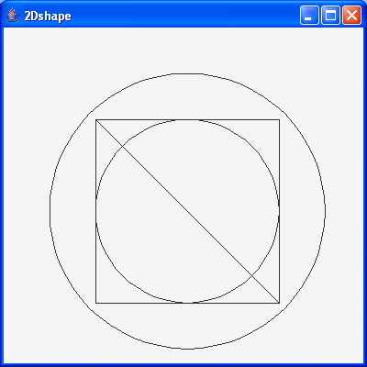

//Assigment-7 write Program that demonstrate text and fonts

import java.awt.*;

import java.awt.*;

import java.awt.geom.*;

import javax.swing.*;

class Fontdemo7

{

public static void main(String s[])

{

MyFrame f=new MyFrame();

f.setVisible(true);

}

}

class MyFrame extends JFrame

{

public MyFrame()

{

setSize(400,400);

setTitle("Font test");

setResizable(false);

}

public void paint(Graphics g)

{

GraphicsEnvironment ge=GraphicsEnvironment.getLocalGraphicsEnvironment();

String s[]=ge.getAvailableFontFamilyNames();

for(int i=0,w=50,h=70;i<s.length;i++)

{

Font f=new Font(s[i],Font.BOLD,20);

g.setFont(f);

g.drawString("Hello World",w,h);

h=h+20;

FontMetrics fm = g.getFontMetrics();

if(h>400)

{

w=w+fm.stringWidth("Hello World")+40;

h=h+20;

}

}

}

}

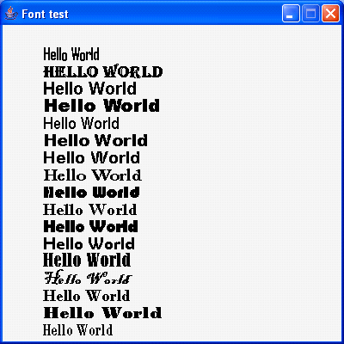

//Assigment-8 write a program that demonstrate event handling for //various types of event

import java.io.*;

import java.awt.event.*;

import javax.swing.*;

import java.awt.*;

public class event

{

public static void main(String a[])

{

myframe f=new myframe();

f.show();

}

}

class myframe extends JFrame

{

mypanel p;

myframe()

{

setSize(500,500);

setVisible(true);

setTitle("event handling ");

p =new mypanel();

Container c=getContentPane();

c.add(p);

}

}

class mypanel extends JPanel

{

int a=0;

JButton b1,b2;

JRadioButton r1,r2;

mylist1 l1;

mylist2 l2;

mylist3 l3;

mypanel()

{

b1=new JButton(" red ");

b2=new JButton(" blue ");

r1=new JRadioButton("black");

r2=new JRadioButton("pink");

l1=new mylist1();

l2=new mylist2();

l3=new mylist3();

b1.addKeyListener(l1);

b2.addKeyListener(l1);

r1.addActionListener(l2);

r2.addActionListener(l2);

addMouseListener(l3);

add(b1);

add(b2);

add(r1);

add(r2);

}

class mylist1 extends KeyAdapter

{

public void keyPressed(KeyEvent k)

{

Graphics g=getGraphics();

char a=k.getKeyChar();

if(a=='r' || a=='R')

{

setBackground(Color.red);

repaint();

}

if(a=='b' || a=='B')

{

setBackground(Color.blue);

repaint();

}

}

}

class mylist2 implements ActionListener

{

public void actionPerformed(ActionEvent e)

{

if(e.getSource()==r1)

{

setBackground(Color.black);

repaint();

}

if(e.getSource()==r2)

{

setBackground(Color.pink);

repaint();

}

}

}

class mylist3 extends MouseAdapter

{

public void mouseClicked(MouseEvent m)

{

a++;

Graphics g=getGraphics();

if(a==1)

{

g.drawString("cliked 1st ",30,50);

//repaint();

}

if(a==2)

{

g.drawString("cliked 2nd ",60,80);

//repaint();

}

if(a==3)

{

a=0;

g.drawString("cliked 3rd ",90,110);

//repaint();

}

}

}

}

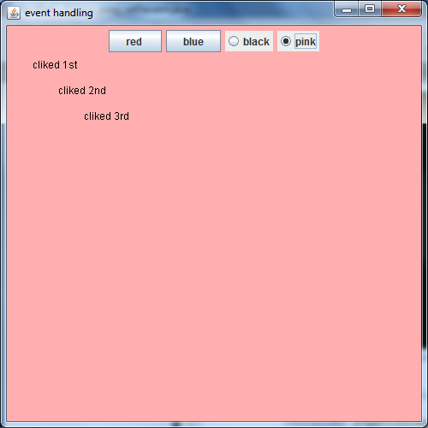

//Assigment-9 write Program to illustrate Multicasting

import java.awt.*;

import java.awt.event.*;

import javax.swing.*;

class MultiCastDemo9

{

public static void main(String s[])

{

MultiCast f=new MultiCast();

f.setVisible(true);

}

}

class MultiCast extends JFrame

{

public MultiCast()

{

setSize(400,400);

setTitle("MultiCast test");

setResizable(false);

addWindowListener(new WindowAdapter()

{

public void windowClosing(WindowEvent e)

{

System.exit(0);

}

});

Container cp=getContentPane();

MultiCastPanel MCP=new MultiCastPanel();

cp.add(MCP);

}

}

class MultiCastPanel extends JPanel implements ActionListener

{

JButton closebtn;

int cnt=0;

public MultiCastPanel()

{

JButton Newbtn=new JButton("NEW");

add(Newbtn);

closebtn=new JButton("CloseAll");

add(closebtn);

Newbtn.addActionListener(this);

}

public void actionPerformed(ActionEvent e)

{

SimpleFrame f = new SimpleFrame();

cnt++;

f.setSize(100,100);

f.setTitle("doc"+cnt);

f.setLocation(cnt*30,cnt*30);

f.show();

closebtn.addActionListener(f);

}

}

class SimpleFrame extends JFrame implements ActionListener

{

public void actionPerformed(ActionEvent e)

{

dispose();

}

}

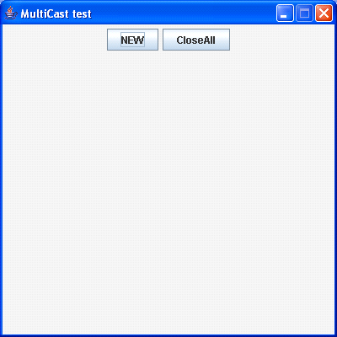

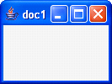 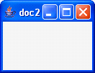 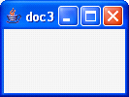

//Assigment-10 write Program to illustrate various Swing components

import java.awt.*;

import java.awt.event.*;

import javax.swing.*;

class SwingDemo10

{

public static void main(String s[])

{

SwingFrame f=new SwingFrame ();

f.setVisible(true);

}

}

class SwingFrame extends JFrame implements ActionListener

{

JButton btn;

JRadioButton r1,r2,r3;

JCheckBox c1,c2,c3,c4;

JTextField text1;

JComboBox cb1;

ButtonGroup gp;

public SwingFrame ()

{

setSize(400,400);

setTitle("SwingComponenttest");

setResizable(false);

Container cp=getContentPane();

JPanel P1=new JPanel();

cp.add(P1,"West");

P1.setLayout(new GridLayout(2,2));

JPanel P2=new JPanel();

cp.add(P2,"South");

P2.setLayout(new FlowLayout());

JPanel P3=new JPanel();

cp.add(P3,"East");

P3.setLayout(new GridLayout(3,1));

P1.add(c1=new JCheckBox("C++ Course"));

P1.add(c2=new JCheckBox("Linux Course"));

P1.add(c3=new JCheckBox("Java Course"));

P1.add(c4=new JCheckBox("Daa Course"));

c1.addActionListener(this);

c2.addActionListener(this);

c3.addActionListener(this);

c4.addActionListener(this);

gp=new ButtonGroup();

P3.add(r1=new JRadioButton("MCA1"));

gp.add(r1);

P3.add(r2=new JRadioButton("MCA2"));

gp.add(r2);

r1.addActionListener(this);

r2.addActionListener(this);

P2.add(btn=new JButton("Print"));

btn.addActionListener(this);

P2.add(text1=new JTextField(27));

}

void getMessage()

{

String sub="";

String year="";

String msg="";

if(c1.isSelected())

sub=sub+"C++ ,";

if(c2.isSelected())

sub=sub+"Linux ,";

if(c3.isSelected())

sub=sub+"Java ,";

if(c4.isSelected())

sub=sub+"Daa ";

if(r1.isSelected())

year="MCA1";

else if(r2.isSelected())

year="MCA2";

msg=" Addmition is in "+year+" subject are "+sub;

text1.setText(msg);

}

public void actionPerformed(ActionEvent e)

{

getMessage();

}

}

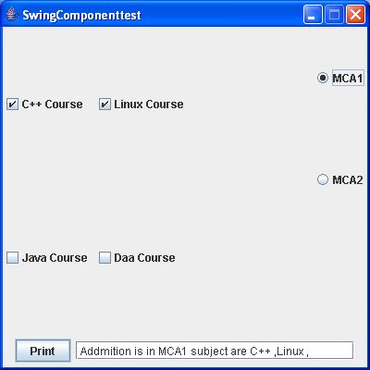

//Assigment-11 write a Program that demonstrate use of Dialog box

import java.awt.*;

import java.awt.event.*;

import javax.swing.*;

import java.sql.*;

class DialogDemo

{

public static void main(String args[])

{

DialogFrame f=new DialogFrame();

//f.setDefaultCloseOperation(3);

f.addWindowListener(new WindowAdapter()

{

public void windowClosing(WindowEvent e)

{

System.exit(0);

}} );

f.setVisible(true);

}

}

class DialogFrame extends JDialog implements ActionListener

{

JComboBox jb;

JPasswordField jpf;

JButton b1,b2;

Container c;

DialogFrame()

{

setSize(250,150);

setTitle("Dialog Testing");

setLocation(400,300);

setResizable(false);

c=getContentPane();

JLabel lab=new JLabel("Name");

JLabel lab1=new JLabel("PassWord");

jb=new JComboBox(new String[]{"Khemchand","Rahul","Raj"});

jpf=new JPasswordField(10);

c.setBackground(new Color(150,70,150));

b1=new JButton("OK");

b2=new JButton("Cancel");

lab.setForeground(Color.white);

lab1.setForeground(Color.white);

jb.setBackground(Color.white);

b1.setBackground(Color.white);

b2.setBackground(Color.white);

c.setLayout(new GridBagLayout());

GridBagConstraints con=new GridBagConstraints();

con.gridwidth=1;

con.gridheight=1;

con.weightx=1;

con.weighty=1;

add1(lab,con,0,0);

add1(jb,con,1,0);

add1(lab1,con,0,1);

add1(jpf,con,1,1);

add1(b1,con,0,2);

add1(b2,con,1,2);

b1.addActionListener(this);

b2.addActionListener(this);

}

public void add1(Component comp,GridBagConstraints gbc,int x,int y)

{

gbc.gridx=x;

gbc.gridy=y;

c.add(comp,gbc);

}

public void actionPerformed(ActionEvent e)

{

String s=(String)jb.getSelectedItem();

String s1=new String(jpf.getPassword());

if(e.getSource()==b1)

{

if(s.equals(s1))

{

JOptionPane.showMessageDialog(c,"Permission ppGrantted Login successufffff");

System.exit(0);

}

else

JOptionPane.showMessageDialog(c,"Wrong PassWord You can't login");

}

else

System.exit(0);

}

}

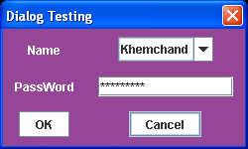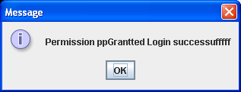

//Assigment-12 write a program to create own dialog box.

import java.io.*;

import java.awt.*;

import javax.swing.*;

import java.awt.event.*;

public class dialog

{

public static void main(String args[])

{

myframe f=new myframe();

f.setSize(400,400);

f.show();

}

}

class myframe extends JFrame

{

myframe()

{

mydialog m=new mydialog();

}

}

class mydialog extends JDialog

{

mypanel p;

mydialog()

{

mypanel p=new mypanel();

Container c=getContentPane();

c.add(p);

setSize(200,200);

show();

}

}

class mypanel extends JPanel implements ActionListener

{

JButton b1;

JTextField t1;

mypanel()

{

b1=new JButton("ok");

t1=new JTextField(10);

b1.addActionListener(this);

add(b1);

add(t1);

}

public void actionPerformed(ActionEvent e)

{

if(e.getSource()==b1)

{

t1.setText("u clicked button");

}

}

}

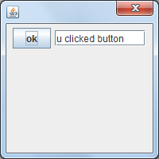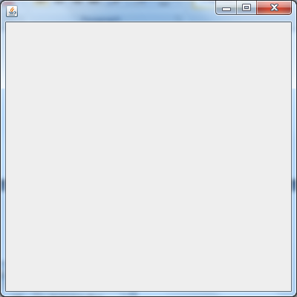

//Assigment-13 write a program to create toolbar, menu & popup menu

import javax.swing.*;

import java.awt.*;

import java.awt.event.*;

class MyFrame extends JFrame

{

JCheckBoxMenuItem rect,circle,line;

JRadioButtonMenuItem pink,blue,red,magenta;

JMenuBar mb;

JMenu shapemenu,colormenu,back,fore;

JPopupMenu pm;

JMenuItem s1,s2,s3;

//MyPanel p ;

public MyFrame()

{

setSize(600,600);

setTitle(" Menu Demo ");

setLocation(200,100);

setResizable(false);

Container c = getContentPane();

mb = new JMenuBar();

shapemenu = new JMenu("Shapes");

colormenu = new JMenu("Colors");

shapemenu.add(rect = new JCheckBoxMenuItem("Rect"));

shapemenu.add(circle = new JCheckBoxMenuItem("Circle"));

shapemenu.add(line = new JCheckBoxMenuItem("Line"));

colormenu.add(back = new JMenu("Background"));

colormenu.add(fore = new JMenu("Foreground"));

back.add(pink = new JRadioButtonMenuItem("Pink",true));

back.add(magenta = new JRadioButtonMenuItem("Magenta"));

ButtonGroup bg1 = new ButtonGroup();

bg1.add(pink);

bg1.add(magenta);

fore.add(red = new JRadioButtonMenuItem("Red",true));

fore.add(blue = new JRadioButtonMenuItem("Blue"));

ButtonGroup bg2 = new ButtonGroup();

bg2.add(red);

bg2.add(blue);

mb.add(shapemenu);

mb.add(colormenu);

class MyPanel extends JPanel implements ActionListener

{

int choice=0;

public MyPanel()

{

setBackground(Color.pink);

setForeground(Color.red);

}

public void paintComponent(Graphics g)

{

//super.paintComponent(g);

switch(choice)

{

case 1:

if(rect.isSelected())

g.drawRect(100,100,100,50); break;

case 2:

if(circle.isSelected())

g.drawOval(200,200,100,50); break;

case 3:

if(line.isSelected())

g.drawLine(100,50,50,100); break;

case 4:

if(pink.isSelected())

setBackground(Color.pink); break;

case 5:

if(magenta.isSelected())

setBackground(Color.magenta); break;

case 6:

if(red.isSelected())

setForeground(Color.red); break;

case 7:

if(blue.isSelected())

setForeground(Color.blue); break;

case 8:

(MyFrame.this).setSize(400,400);

break;

case 9:

(MyFrame.this).setSize(500,500);

break;

case 10:

(MyFrame.this).setSize(600,600);

break;

}

}

public void actionPerformed(ActionEvent e)

{

Object obj = e.getSource();

if(obj == rect)

choice = 1;

else if(obj == circle)

choice = 2;

else if(obj == line)

choice = 3;

else if(obj == pink)

choice = 4;

else if(obj == magenta)

choice = 5;

else if(obj == red)

choice = 6;

else if(obj == blue)

choice = 7;

else if(obj == s1)

choice = 8;

else if(obj == s2)

choice = 9;

else if(obj == s3)

choice = 10;

repaint();

}

}

class MouseHandler extends MouseAdapter

{

public void mouseClicked(MouseEvent e)

{

if(e.getModifiers() == MouseEvent.BUTTON3_MASK)

pm.show(MyFrame.this,e.getX(),e.getY());

}

}

MyPanel p = new MyPanel();

c.add(p,"Center");

c.add(mb,"North");

pm = new JPopupMenu();

pm.add(s1 = new JMenuItem("400 * 400"));

pm.add(s2 = new JMenuItem("500 * 500"));

pm.add(s3 = new JMenuItem("600 * 600"));

rect.addActionListener(p);

circle.addActionListener(p);

line.addActionListener(p);

red.addActionListener(p);

blue.addActionListener(p);

magenta.addActionListener(p);

pink.addActionListener(p);

s1.addActionListener(p);

s2.addActionListener(p);

s3.addActionListener(p);

p.addMouseListener(new MouseHandler());

}

}

class MenuDemo

{

public static void main(String[]args)

{

MyFrame f = new MyFrame();

f.setVisible(true);

f.setDefaultCloseOperation(3);

}

}

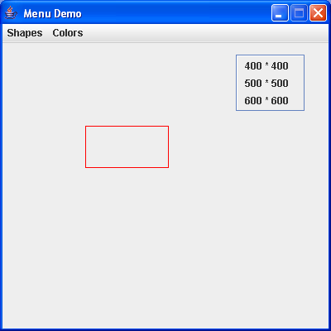

//Assigment-14 write a program to implement file handlings.

import java.io.*;

class FileHandling

{

public static void main(String args[]) throws IOException

{

File primitive=new File("prim.txt");

FileOutputStream fos=new FileOutputStream(primitive);

DataOutputStream dos=new DataOutputStream(fos);

dos.writeInt(2002);

dos.writeDouble(123.45);

dos.writeBoolean(true);

dos.writeChar('A');

dos.writeUTF("Hello JAVA ...!");

dos.close();

fos.close();

FileInputStream fis=new FileInputStream(primitive);

DataInputStream dis=new DataInputStream(fis);

System.out.println(dis.readInt());

System.out.println(dis.readDouble());

System.out.println(dis.readBoolean());

System.out.println(dis.readChar());

System.out.println(dis.readUTF());

dis.close();

fis.close();

}

}

output:-

2002

123.45

true

A

Hello JAVA ...!

Press any key to continue . . .

//Assigment-15 write a program that demonstrate Applet programming.

/*

<applet

code = AppletMaximum

height=500

width=500>

</applet>

*/

import java.applet.*;

import javax.swing.*;

import java.awt.*;

import java.awt.event.*;

class MyPanel extends JPanel implements ActionListener

{

JButton btn;

JTextField tf1,tf2,tf3;

public MyPanel()

{

setBackground(Color.magenta);

add(new JLabel("Number1"));

add(tf1 = new JTextField(4));

add(new JLabel("Number2"));

add(tf2 = new JTextField(4));

add(new JLabel("Number3"));

add(tf3 = new JTextField(4));

add(btn = new JButton("Max"));

btn.addActionListener(this);

}

public void actionPerformed(ActionEvent e)

{

try

{

int max=0;

int no1 = Integer.parseInt(tf1.getText());

int no2 = Integer.parseInt(tf2.getText());

int no3 = Integer.parseInt(tf3.getText());

if(no1>no2)

{

if(no1>no3)

max = no1;

else

max = no3;

}

else

{

if(no2>no3)

max = no2;

else

max = no3;

}

JOptionPane.showMessageDialog(this,"Maximum Number = "+max,"Maximum

Test",JOptionPane.INFORMATION_MESSAGE);

}

catch(NumberFormatException e1)

{

JOptionPane.showMessageDialog(MyPanel.this,"You must enter the Number");

}

}

}

public class AppletMaximum extends JApplet

{

public void init()

{

Container c = getContentPane();

c.add(new MyPanel());

}

}

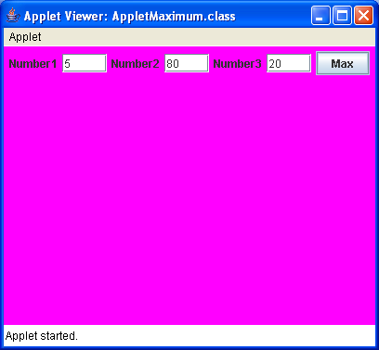

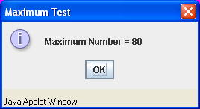

//Assigment-16 write a program to implement generic program.

import java.io.*;

import java.util.*;

public class Array

{

public static void main(String ab[])

{

ArrayList a=new ArrayList();

a.add("AA");

a.add("AB");

a.add("AC");

ListIterator l=a.listIterator();

while(l.hasNext())

{

System.out.println(l.next());

}

}

}

AA

AB

AC

Press any key to continue . . .

//Assigment-17 write a program that demonstrate JDBC on applet/application.

import java.awt.*;

import java.awt.event.*;

import javax.swing.*;

import java.sql.*;

class myframe extends JFrame

{

myframe()

{

setSize(500,500);

setLocation(100,100);

setTitle("simple");

Container cp=getContentPane();

mypanel p=new mypanel();

cp.add(p);

}

}

class mypanel extends JPanel

{

Connection con;

mypanel()

{

try

{

Class.forName("sun.jdbc.odbc.JdbcOdbcDriver");

con=DriverManager.getConnection("jdbc:odbc:sh","","");

Statement state=con.createStatement();

ResultSet rs=state.executeQuery("select * from stud");

System.out.println("Records are as Follows=>>>>>>>>>>>>>>>>>>>>");

System.out.println(" ");

while(rs.next())

{

System.out.print(rs.getInt("rno")+" ");

System.out.println(rs.getString("name"));

}

}

catch(Exception e)

{

System.out.println("Exp="+e);

}

}

}

public class aaa

{

public static void main(String d[])

{

myframe m=new myframe();

m.show();

}

}

Records are as Follows=>>>>>>>>>>>>>>>>>>>>

6 eee

7 fff

2 aaaa

3 bbb

4 ccc

5 ddd

//Assigment-18 write a program that demonstrate Multithreading.

import java.io.*;

import java.awt.*;

class multhread

{

public static void main(String args[])

{

Thread t=Thread.currentThread();

System.out.println("My thread name is "+t.getName()+"is active"+t.isAlive());

t.setName("threadDemoMain");

System.out.println("My thread new name is "+t.getName()+"and Priority is->"+t.getPriority());

System.out.println("SLEEPING THE THREAD FOR 1000");

try

{

for(int i=0;i<5;i++)

{

t.sleep(1000);

System.out.println("value of [i] is ["+i+"]");

}

}

catch(Exception e)

{

System.out.println("The Thread is interupted["+e+"]");

}

System.out.println("SLEEPS ENDS HERE");

}

}

/*output:-

My thread name is mainis activetrue

My thread new name is threadDemoMainand Priority is->5

SLEEPING THE THREAD FOR 1000

value of [i] is [0]

value of [i] is [1]

value of [i] is [2]

value of [i] is [3]

value of [i] is [4]

SLEEPS ENDS HERE

Press any key to continue . . .*/